QUICK ESCAPE
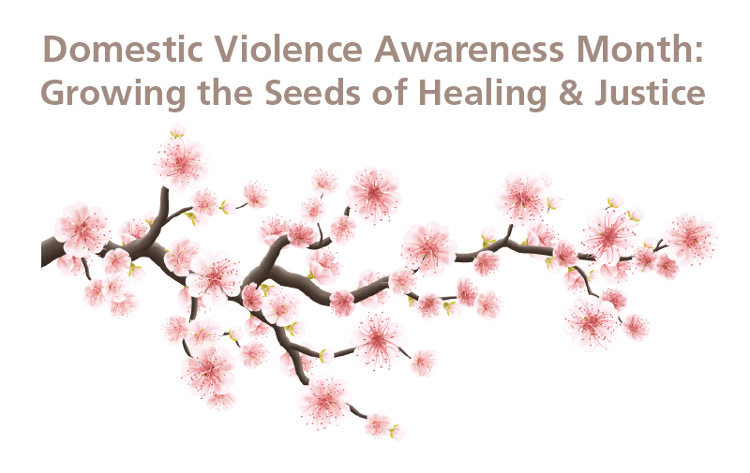
Survey for Survivors | Growing the Seeds of Healing & Justice Campaign
It’s vital that survivors are centered and heard in efforts to educate policymakers and the public – so for Domestic Violence Awareness Month, we want to provide a platform for you to share the future you want to see. Our campaign, Growing the Seeds of Healing & Justice, will center your input in eight different areas:
- Accountability
- Economic Equity
- Gender Justice
- Racial Justice/Decolonization
- Disability Justice
- Embracing Sexual Orientation
- Faith-Based Support
- The Future
We invite you to participate in our survey, where you’ll be asked some questions in each area. These broadly focus on how you’d feel more supported, what changes need to be made in communities to make healing & justice more accessible, and your hopes for the future. Feel free to explore all the questions before answering them by clicking "next" below. You can answer as many or as few as you’d like, and including your name is completely optional.
We encourage survivors of all genders and sexual identities to respond, including people who identify as gender fluid, trans, Two Spirit, nonbinary, lesbian, gay, bisexual, pansexual, and asexual.
Responding to these questions may be triggering, so please feel free to reach out to us at info@cpedv.org for support. Our offices are open Monday-Friday from 8:30-5:00 p.m. We will link you to local advocates who are available to talk 24 hours a day, 7 days a week. You can also visit our map of domestic violence member programs (bit.ly/ca-dv-programs) to find support. Need immediate assistance? You can contact the National Domestic Violence Hotline at 1-800-799-SAFE (7233) or TTY 1-800-787-3224, or visit https://www.thehotline.org/ to chat with an advocate.
Your input will be visually represented in an infographic of a cherry blossom tree. The quotes you include in this survey will bloom from flowering branches, emerging from the eight root areas listed above. We plan to share this throughout our communication channels in the upcoming months as part of our Domestic Violence Campaign.
We sincerely appreciate your consideration. Feel free to email Jessica Merrill, Communications Manager, with any questions at jessica@cpedv.org.

QUICK ESCAPE
Next

QUICK ESCAPE
Survey for Survivors | Growing the Seeds of Healing & Justice Campaign
Before you begin: If you begin to feel triggered by any of these questions, please feel free to reach out to us at info@cpedv.org for support. Our offices are open Monday-Friday from 8:30-5:00 p.m. We will link you to local advocates who are available to talk 24 hours a day, 7 days a week. You can also visit our map of domestic violence member programs (bit.ly/ca-dv-programs) to find support. We will link you to local advocates who are available to talk 24 hours a day, 7 days a week. Need immediate assistance? You can contact the National Domestic Violence Hotline at 1-800-799-SAFE (7233) or TTY 1-800-787-3224, or visit https://www.thehotline.org/ to chat with an advocate.
Please note that each question has a limit of 250 characters to ensure fit onto our Domestic Violence Awareness Month infographic. You may answer as few or as many questions as you’d like. Responses are subject to light editing for clarity.
Your name (optional – please leave blank if desired)
First Name:
Last Name:
Would you like your name listed alongside your survey responses in our Domestic Violence Awareness Month materials? We will not publish any identifying information unless we have your permission to do so. If this field is left blank, we will not include your name.
Yes, include my name with my survey responses in the Partnership's Domestic Violence Awareness Month materials.
No, do not include my name with my survey responses in the Partnership's Domestic Violence Awareness Month materials.
Your email (optional– please leave blank if you do not want to be contacted).
Accountability
1. What would you need from the person who caused you harm to feel they've held themselves accountable?
2. What would you need from your friends, family, and community to feel safer and cared for?
Economic Equity
3. What works to ensure you have access to safe, stable housing?
Racial Justice/ Decolonization
The following two questions are for Native and immigrant survivors, as well as survivors of color:
4. How do support systems need to be improved to meet your needs?
5. What policies would enhance/would have enhanced your safety as a Native or immigrant survivor, or survivor of color?
Disability Justice
The following question is for survivors who are disabled:
6. How do support systems need to be improved to meet your needs?
Gender Justice
7. Given that one of the root causes of DV is rigid gender roles, what changes in your community would enhance the feeling of being accepted for who you are? We encourage survivors of all genders to respond, including people who identify as gender fluid, trans, Two Spirit, and nonbinary.
Embracing Sexual Orientation
The following question is for survivors who are lesbian, gay, bisexual, pansexual, or asexual:
8. How can schools, workplaces religious institutions, etc. create welcoming environments for lesbian, gay, bisexual, pansexual, and asexual survivors, and how would this work to prevent abusive tactics?
Faith-Based Support
9. How can faith-based institutions support and care for individuals and families experiencing abuse?
10. How can faith-based institutions change the social norms that contribute to domestic violence?
The Future
11. How do we move toward a California free from domestic violence?
12. What is your hope for future generations?
We sincerely appreciate your participation in this survey. Please remember that we will not publish any identifying information unless you provided permission at the beginning of this survey.

QUICK ESCAPE

cpedv.org/healing-justice
We sincerely appreciate your participation in this survey.
If you begin to feel triggered by any of these questions, please feel free to reach out to us at info@cpedv.org for support. Our offices are open Monday-Friday from 8:30-5:00 p.m. We will link you to local advocates who are available to talk 24 hours a day, 7 days a week. You can also visit our map of domestic violence member programs to find support. We will link you to local advocates who are available to talk 24 hours a day, 7 days a week. Need immediate assistance? You can contact the National Domestic Violence Hotline at 1-800-799-SAFE (7233) or TTY 1-800-787-3224, or visit https://www.thehotline.org/ to chat with an advocate.

